A Mini Project Synopsis on
Student Management System

S.E. - I.T Engineering

Submitted By
Ishaan Jambhekar 21104122
Mrunmayi Joshi 21104018
Tanaya Kulkarni 21104011

Under The Guidance Of
Prof. Manasi Choche



DEPARTMENT OF INFORMATION TECHNOLOGY
A.P.SHAH INSTITUTE OF TECHNOLOGY
G.B. Road, Kasarvadavali, Thane (W), Mumbai-400615
UNIVERSITY OF MUMBAI

Academic year: 2022-23

CERTIFICATE

This to certify that the Mini Project report on Student Management System has been submitted by Ishaan Jambhekar (21104122), Mrunmayi Joshi (21104018) and Tanaya Kulkarni (21104011) who are a Bonafede students of A. P. Shah Institute of Technology, Thane, Mumbai, as a partial fulfilment of the requirement for the degree in Information Technology, during the academic year 2022-2023 in the satisfactory manner as per the curriculum laid down by University of Mumbai.

Ms. Manasi Choche
Guide

Dr. Kiran Deshpande Dr. Uttam D.Kolekar
Head Department of Information Technology Principal

External Examiner(s)
1.
2.
Place: A.P. Shah Institute of Technology, Thane
Date:

ACKNOWLEDGEMENT

This project would not have come to fruition without the invaluable help of our guide Prof. Manasi Choche. Expressing gratitude towards our HoD, Dr. Kiran Deshpande, and the Department of Information Technology for providing us with the opportunity as well as the support required to pursue this project. We would also like to thank our teacher Ms. Manasi Choche who gave us her valuable suggestions and ideas when we were in need of them. We would also like to thank our peers for their helpful suggestions.

TABLE OF CONTENTS

- Introduction.......................................................................................................... 1
  - Purpose..................................................................................................... 1
  - Objectives................................................................................................. 1
  - Scope........................................................................................................ 2
- Problem Definition………………….................................................................... 3
- Proposed System………....................................................................................... 4
  - Features and Functionality…………………………………………………...4
- Project Outcomes.................................................................................................. 7
- Software Requirements ........................................................................................ 8
- Project Design........................................................................................................9
- Project Scheduling……………………………………………………………….15
- Conclusion………..................................................................................................16
References

Chapter 1
1. Introduction
1.1 Purpose:
Student Information Management System can be used by education institutes to maintain the records of students easily. Achieving this objective is difficult using a manual system as the information is scattered, can be redundant and collecting relevant information may be very time consuming. All these problems are solved using this project.
The main purpose is to illustrate the requirements of the project Student information System and is intended to help any organization to maintain and manage its student’s personal data.
1.2 Objectives:
The objective of Student information System is to allow the administrator of any organization to edit and find out the personal details of a student and allows the student to keep up to date his profile.
1.3 Scope
Without a Student information System, managing and maintaining the details of the student is a tedious job for any organization. Student Information system will store all the details of the students including their background information, educational qualifications, personal details and all the information.
Chapter 2
2. Problem Definition
The College Management has to handle records for many number of students and maintenance was difficult. Though it has used an information system, it was totally manual. Hence there is a need to upgrade the system with a computer based information system.
EXISTING SYSTEM:
All the details of the student are maintained in a single record.
So searching and upgrading the details is a tedious task. Also there is a chance of errors.
PROPOSED SYSTEM:
By developing the system we can attain the following features:
• Easy to handle and feasible
•Cost Reduction
• Fast and Convenient

Chapter 3
3. Proposed System
3.1 Features and Functionality
The Student Information System is aimed towards recording a considerable number of student records and needs online assistance for managing records of students. Website should be user-friendly, ‘quick to learn’ and reliable website for the above purpose.
The features that are available to the Administrator are:
- An Administrator can login into the system and perform any of the available operations.
- Administrator who can view and edit the details of any students.
-Administrator can Add , Delete, Update, Search Student and Shows Details of the Students.
- Helps systematic study of data.
- Providing statics in a sorted tabular form.
- Tuples like Phone number, email Ids, address, Student Ids are assigned to each individual student.

Chapter 4
Project Outcomes
User Can get analysis of student information.
This project shows the recent login time and date details.
Administrator can search , add , delete , update about each individual.
We can export data as well using database.

Chapter 5
5. Software Requirements
front end ( GUI ) & Backend (Database)
- Python version 3.10 using pycharm
- Python with tkinter is the fastest and easiest way to create the GUI application.
- MySql database Connectivity.

Chapter 6
6. Project Design
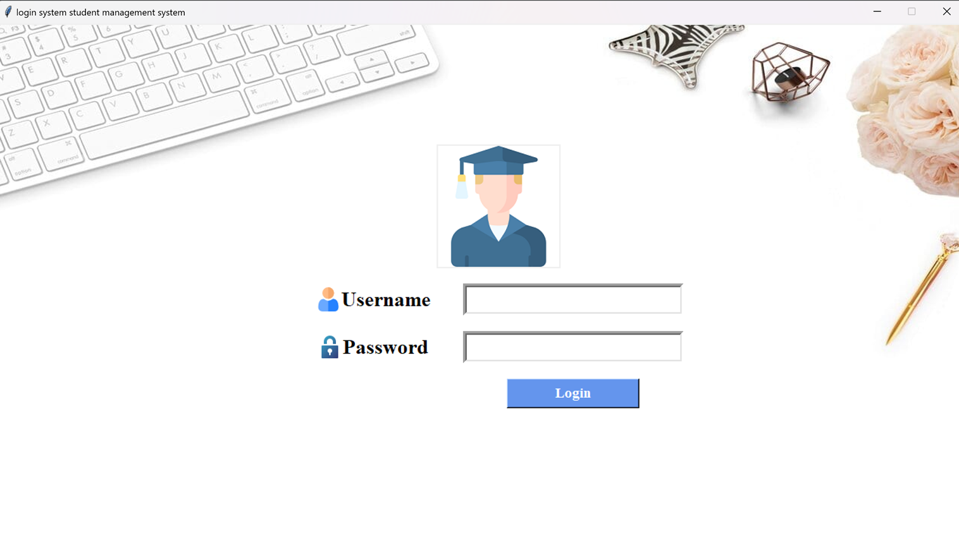
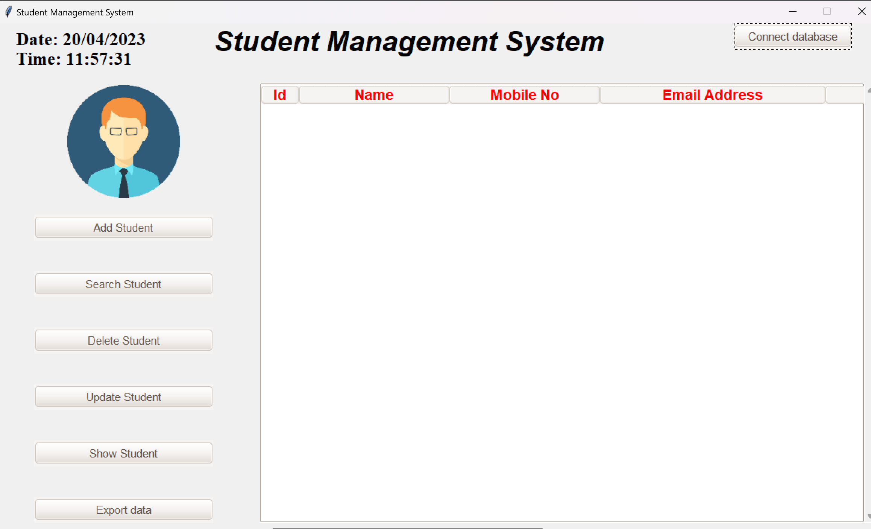

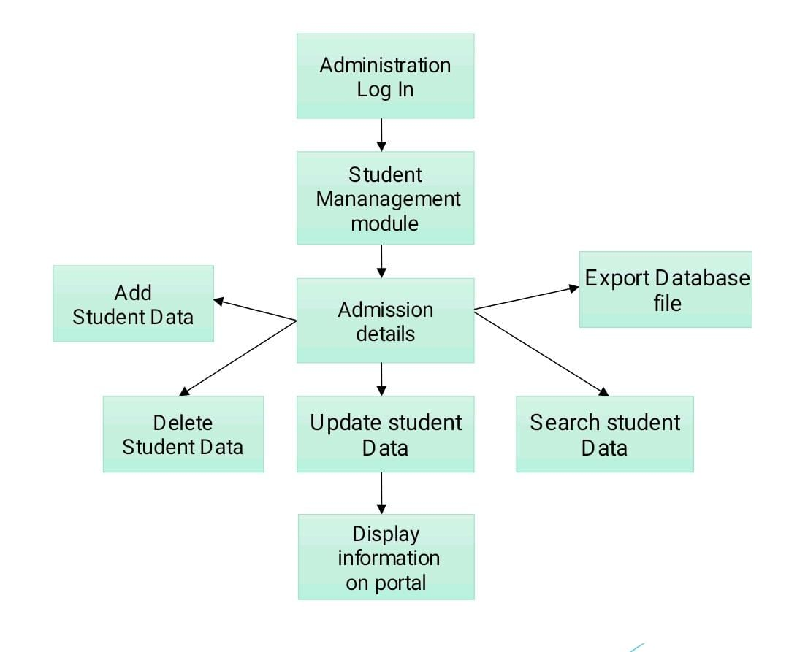

Chapter 8
8 .Conclusion
The final thesis can say that the created GUI of student management system displays the information regarding different sections of student’s profile.
Administrator stores students details in database with various functions.
Using technology stack of python – pycharm, tkinter and MySQL connectivity we therefore present you this project.

